**Installation of MinIO services for Semantic type functionality.**

|  |  |  |
| --- | --- | --- |
| Signatures by each signatory indicate their acceptance that this document is complete and accurate to the best of his/her knowledge per responsibilities outlined in this document and as guided by approved methodologies and established procedures. | | |
| **Team Lead:**  **Artha Emp** | **Omkar Patil** | **Date:** |
| **Project Manager:**  **Artha Emp** | **Deepthi Dharamsagar** | **Date:** |
| **Talend Developer:**  **Artha Emp** | **Omkar** | **Date:** |

**Step 1: - Talend Semantic Type Services available in High level license.**

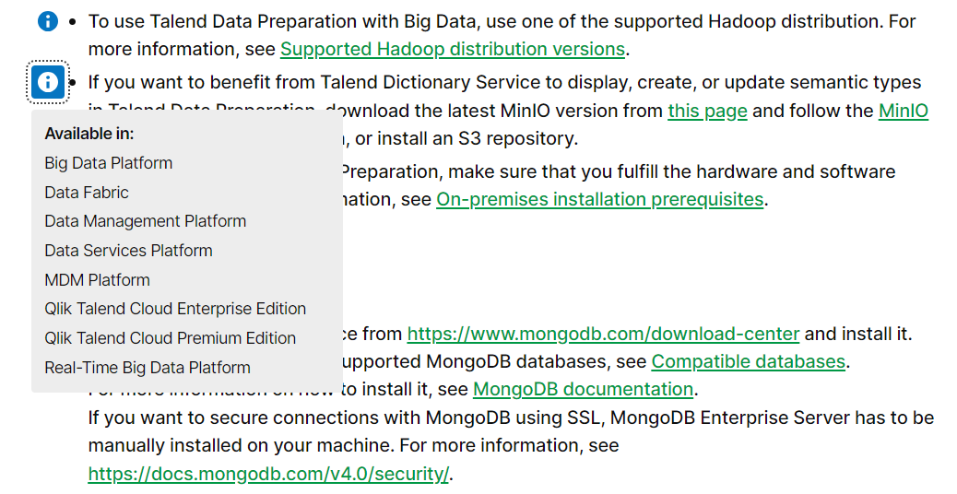

**\*\*Talend Dictionary service\*\***

<https://help.talend.com/en-US/installation-guide-linux/8.0/configuring-and-starting-talend-dictionary-service?ver=15>

**\*\*Talend Data prep\*\***

<https://help.talend.com/en-US/installation-guide-windows/8.0/installing-talend-data-preparation-manually>

**\*\*Talend Data stewardship\*\***

<https://help.talend.com/en-US/installation-guide-windows/8.0/installing-talend-data-stewardship-manually>

**Step 2: - Commands to install MinIO service**

<https://min.io/docs/minio/linux/index.html?ref=docs-redirect>

**According to servers copy the commands**

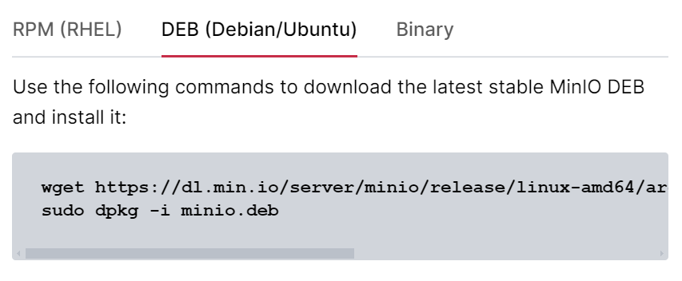

**wget** [**https://dl.min.io/server/minio/release/linux-amd64/archive/minio_20240716234641.0.0_amd64.deb -O minio.deb**](https://dl.min.io/server/minio/release/linux-amd64/archive/minio_20240716234641.0.0_amd64.deb%20-O%20minio.deb)

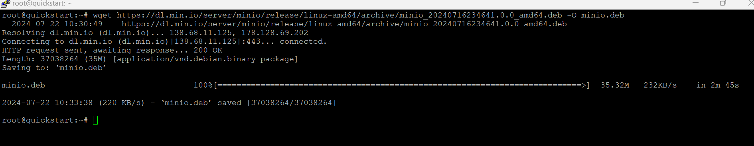

**sudo dpkg -i minio.deb**

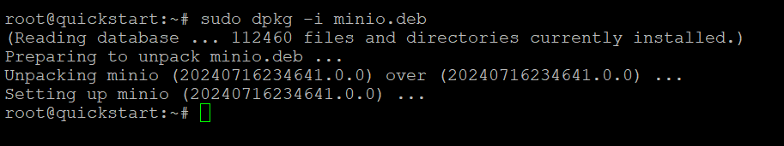

**mkdir ~/minio**

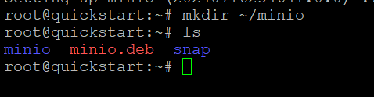

**minio server ~/minio --console-address :9001**

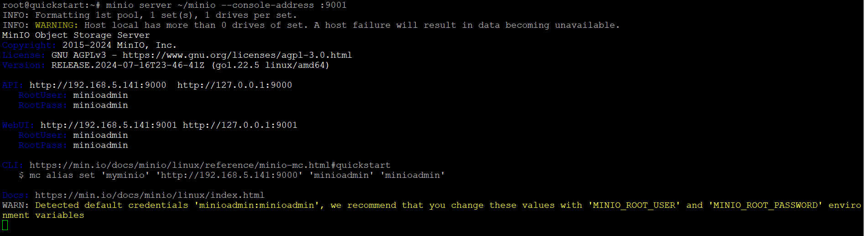

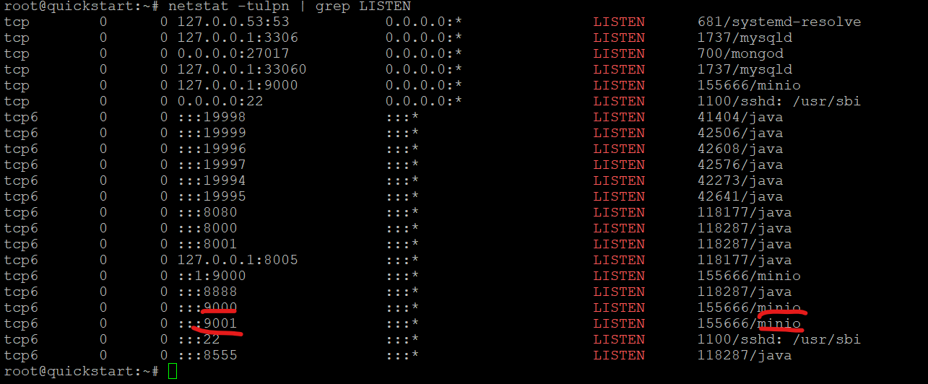

**Don’t stop the process just close the server and connect fresh**

Default username :- **minioadmin**

Default Password:- **minioadmin**

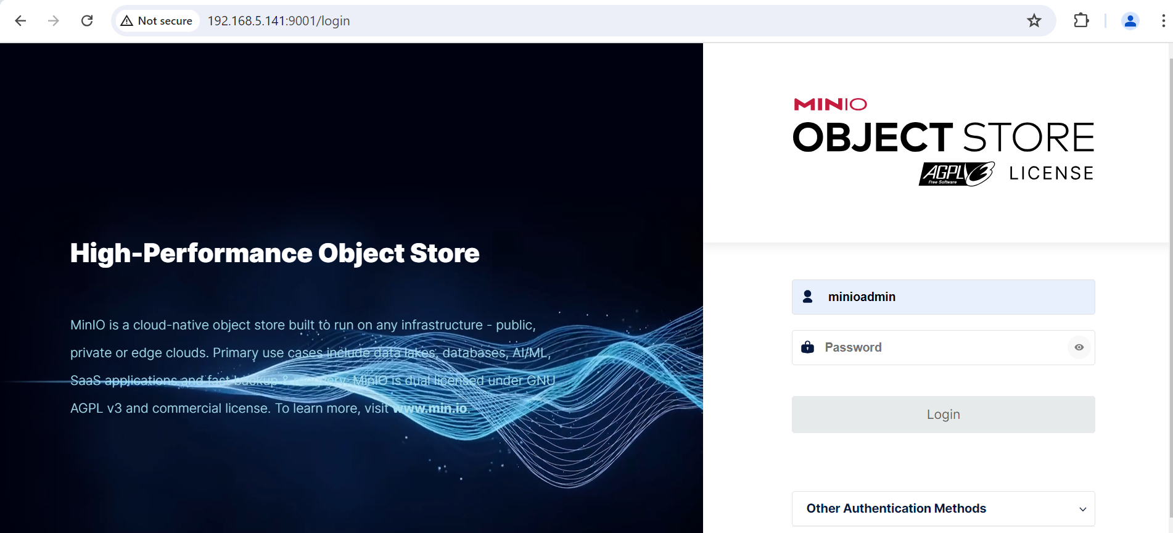

**\*Create the User with same as same Talend TAC User**

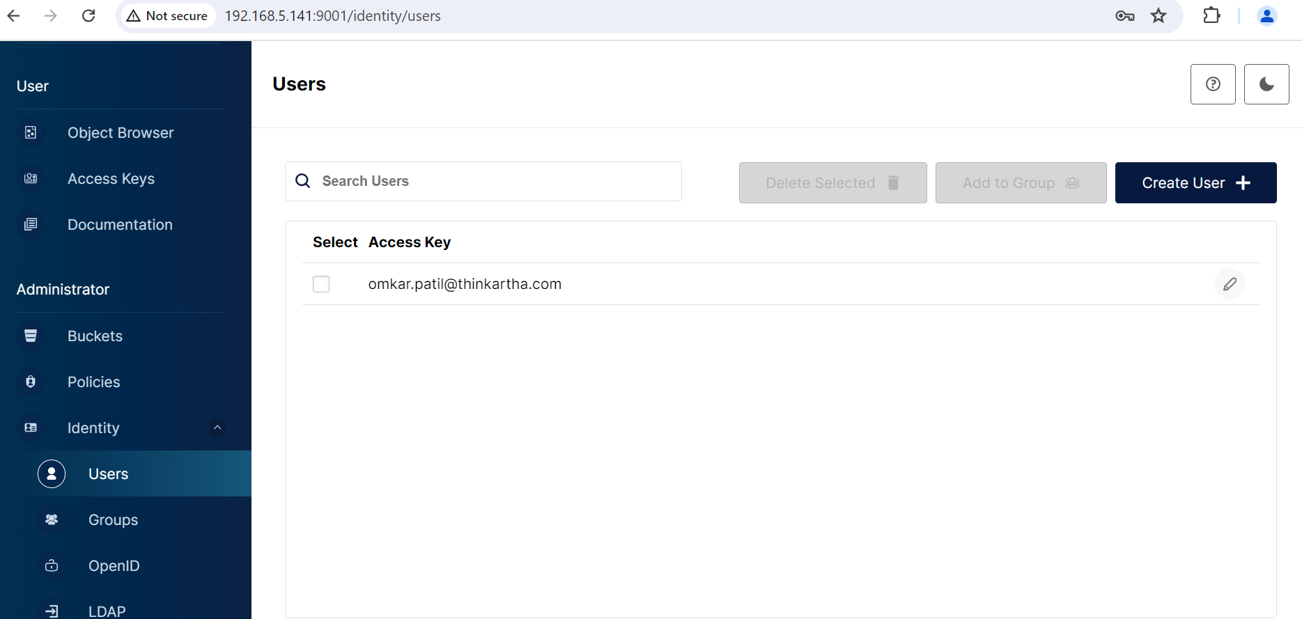

**\*Login with this user and create Bucket**

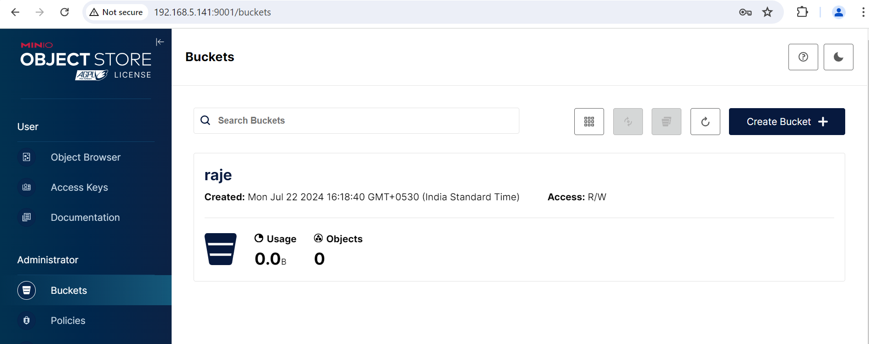

**Step 3:- configuration files of TDP, TDS for DQ services (MinIO)**

